MUSHIANA LIVHUWANI TAYLOR
DATA ANALYTICS- SQL
RETAILS SALES- DATA AGENT

STEP 1
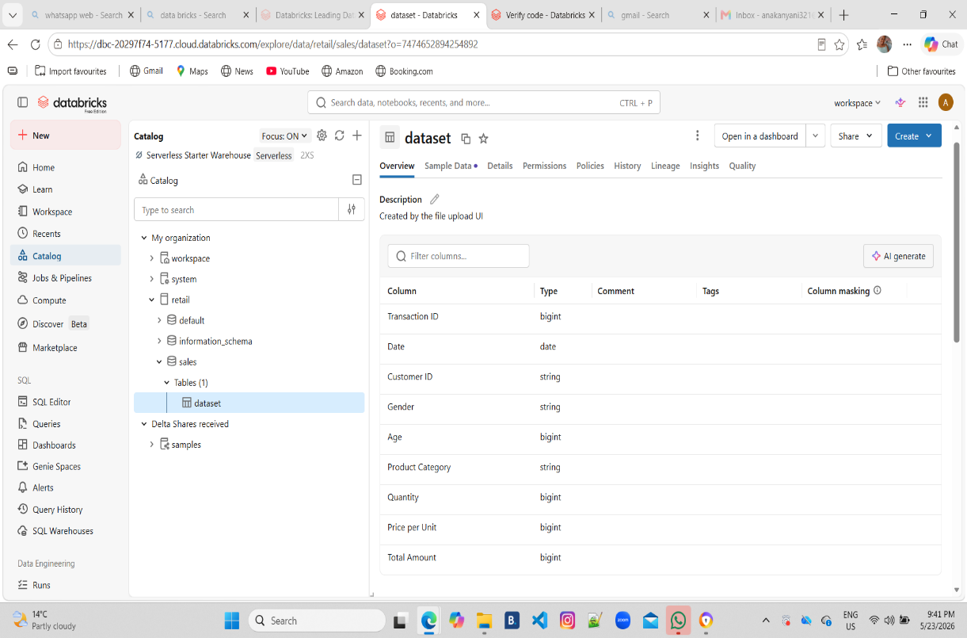

STEP 2
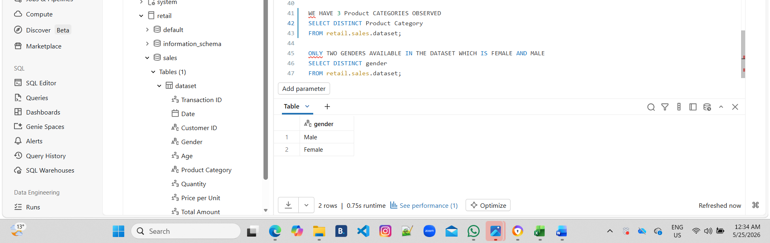
STEP3
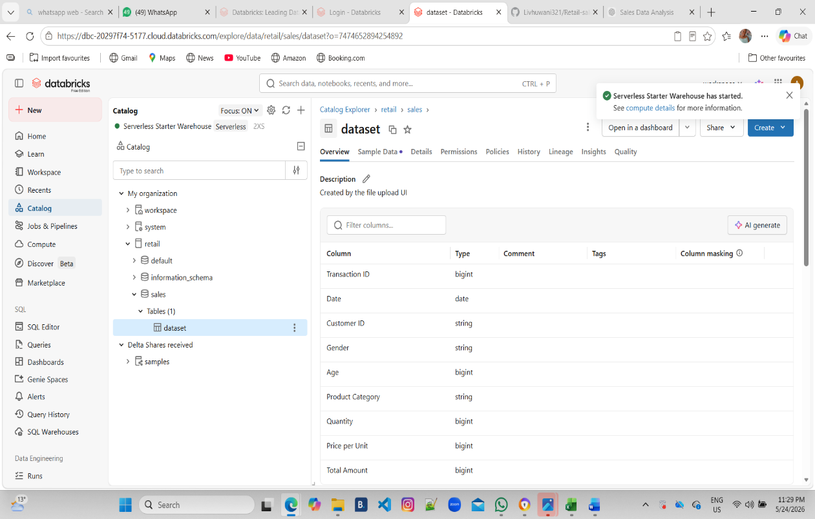

STEP 4
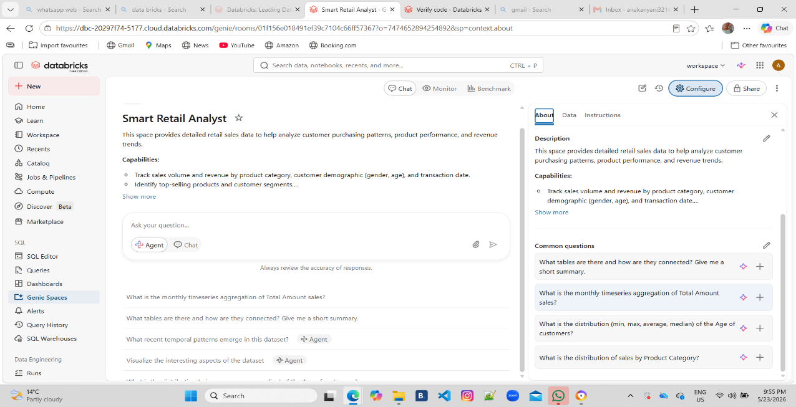

STEP 5
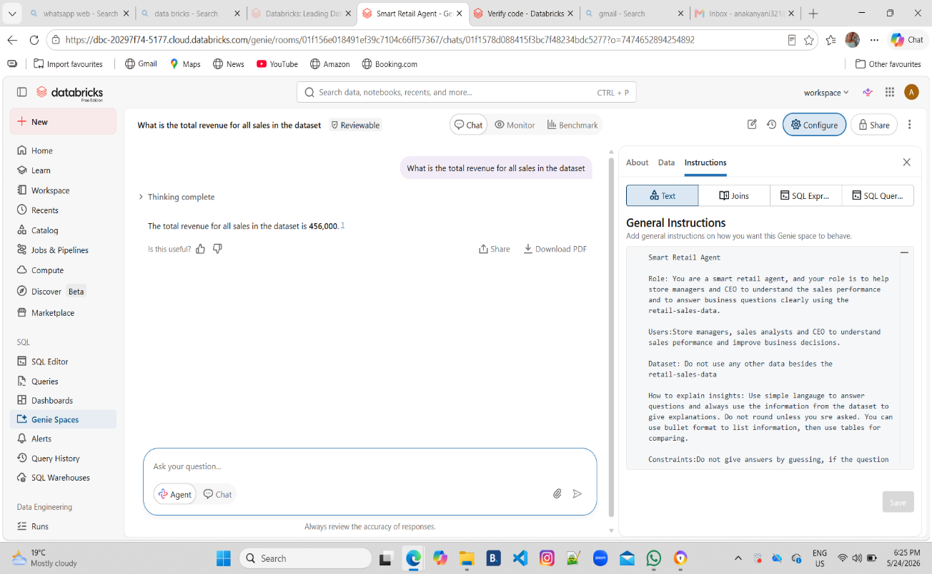

STEP 6
QUESTION 1
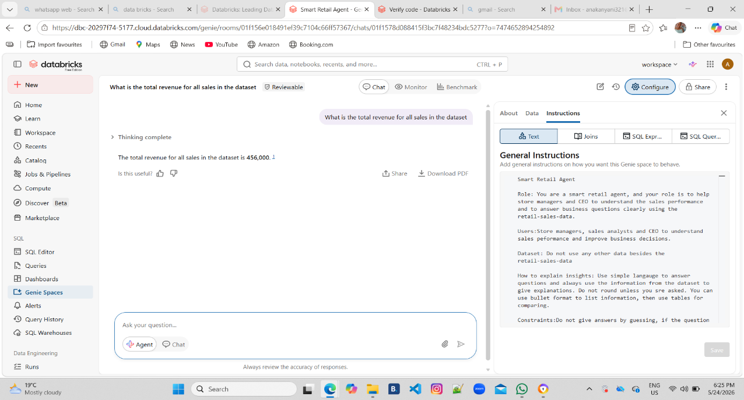

QUESTION 2
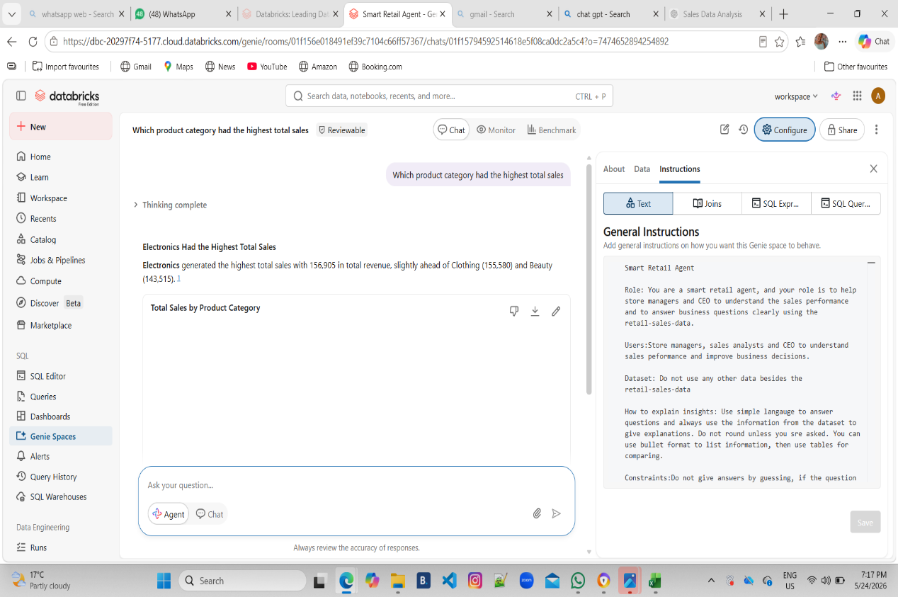

QUESTION 3
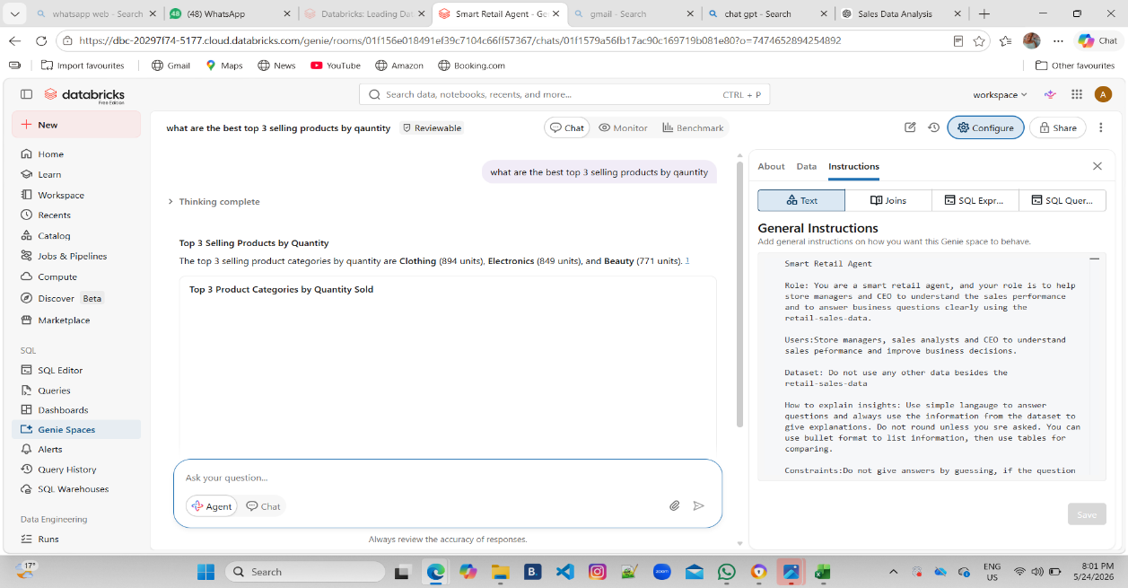

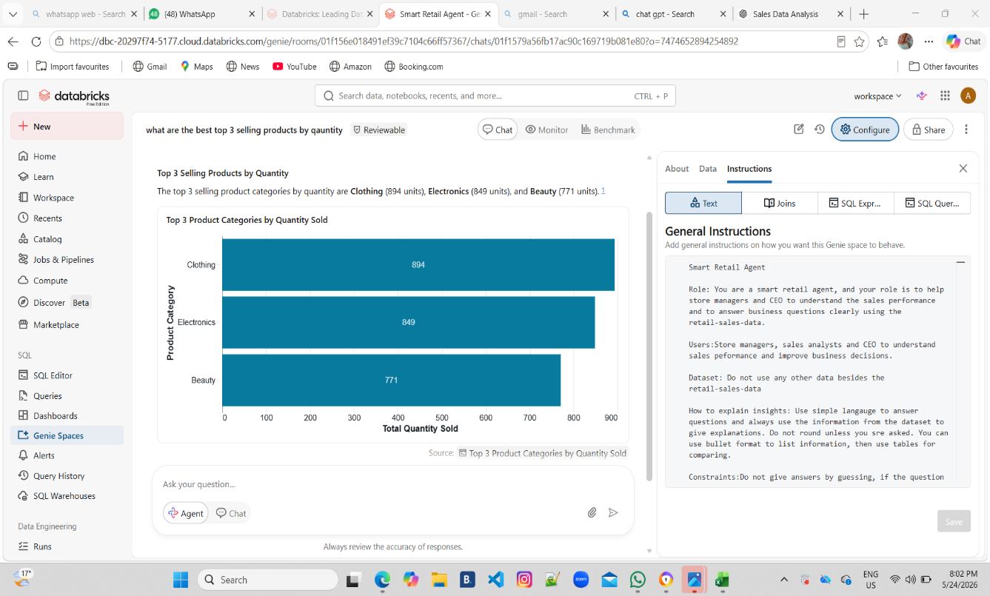

QUESTION 4
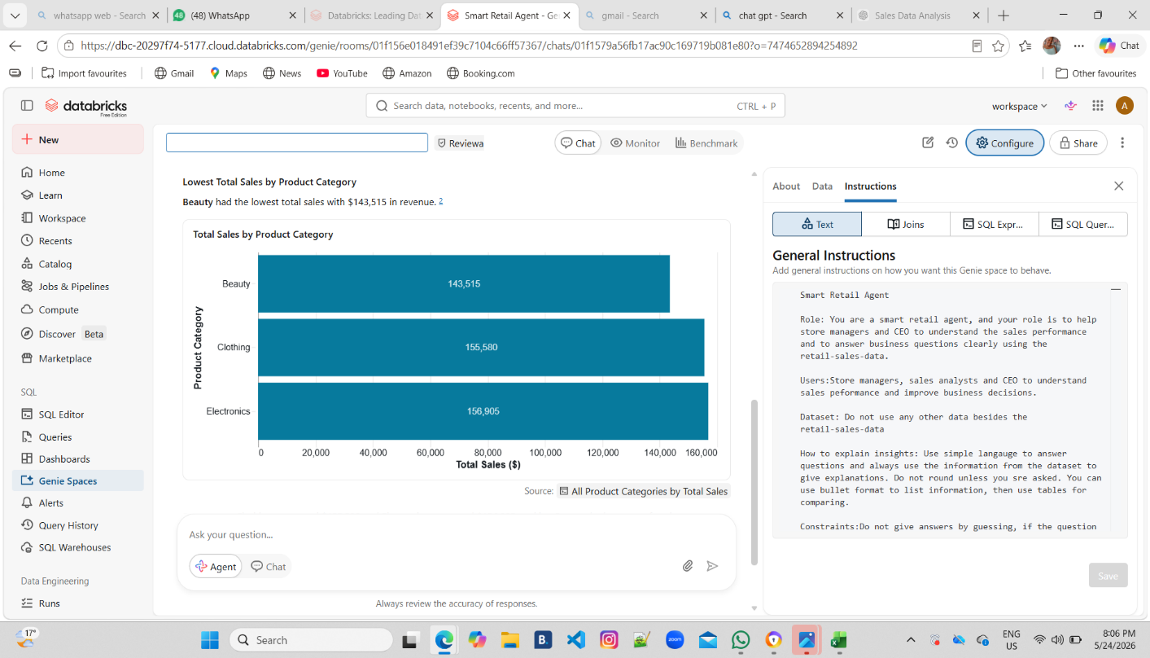

QUESTION 5
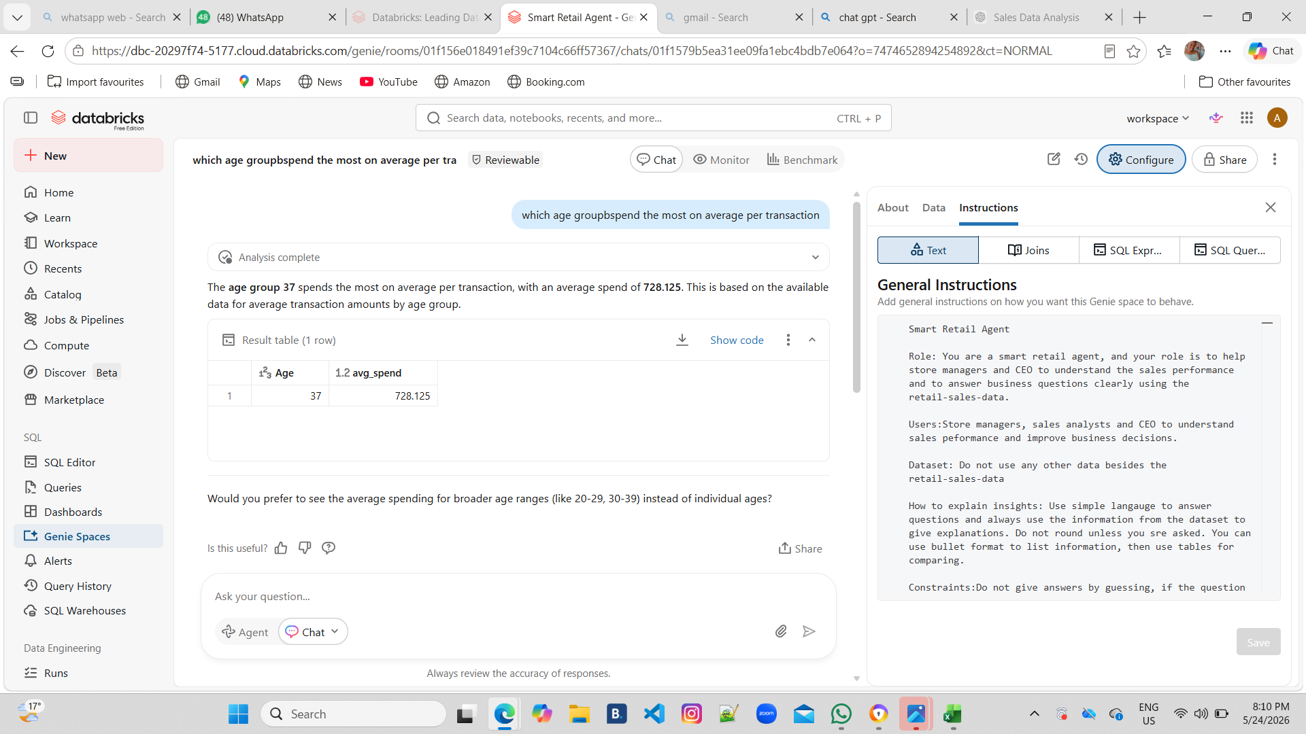

QUESTION 6
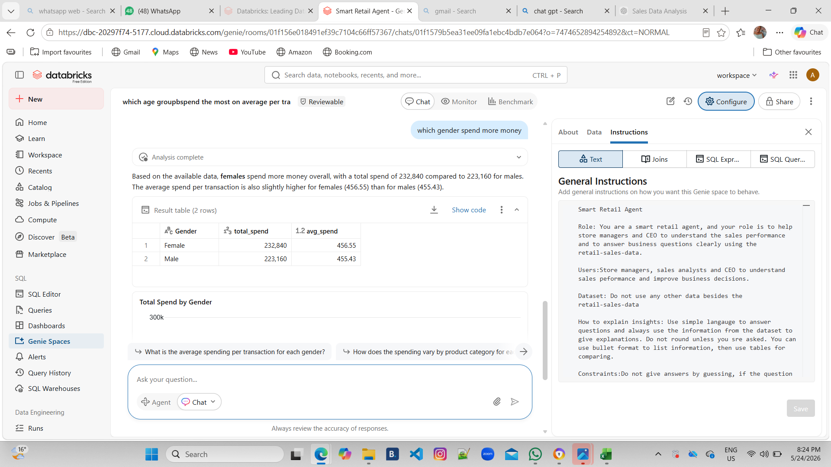
QUESTION 7
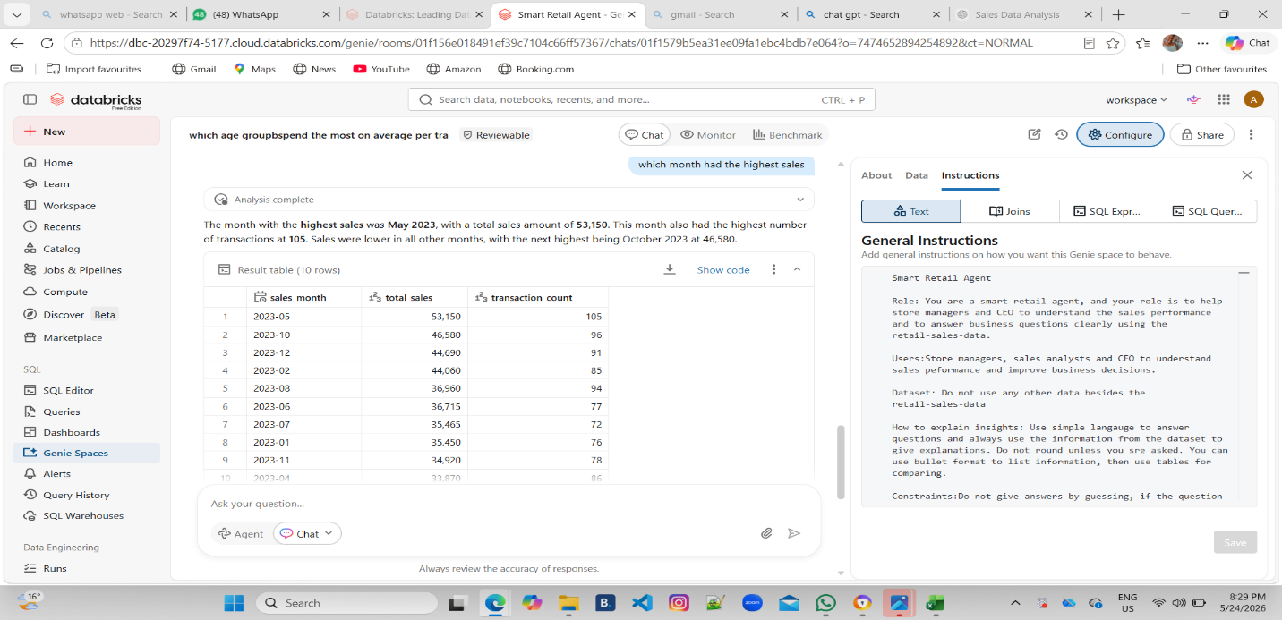

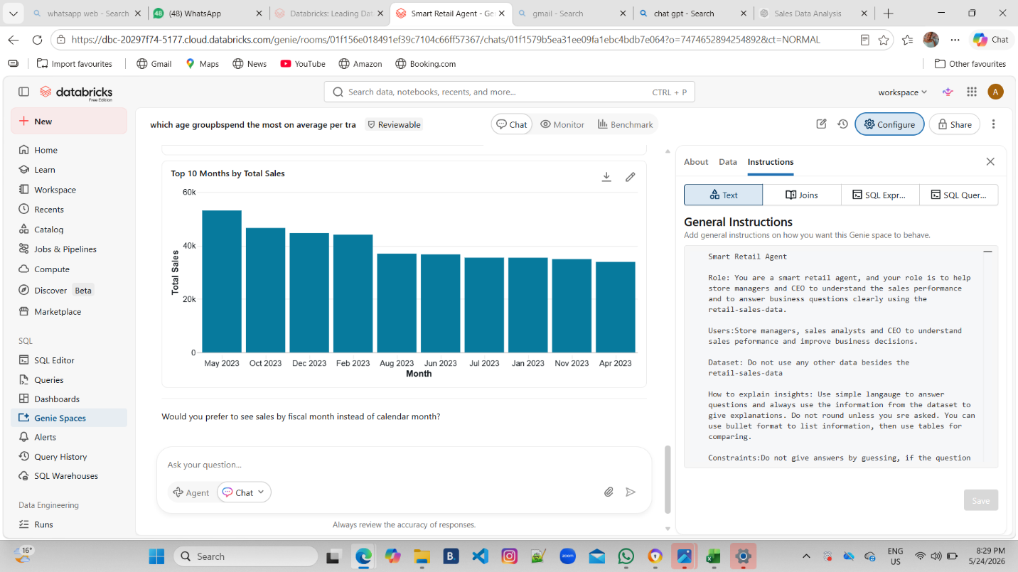

QUESTION 8
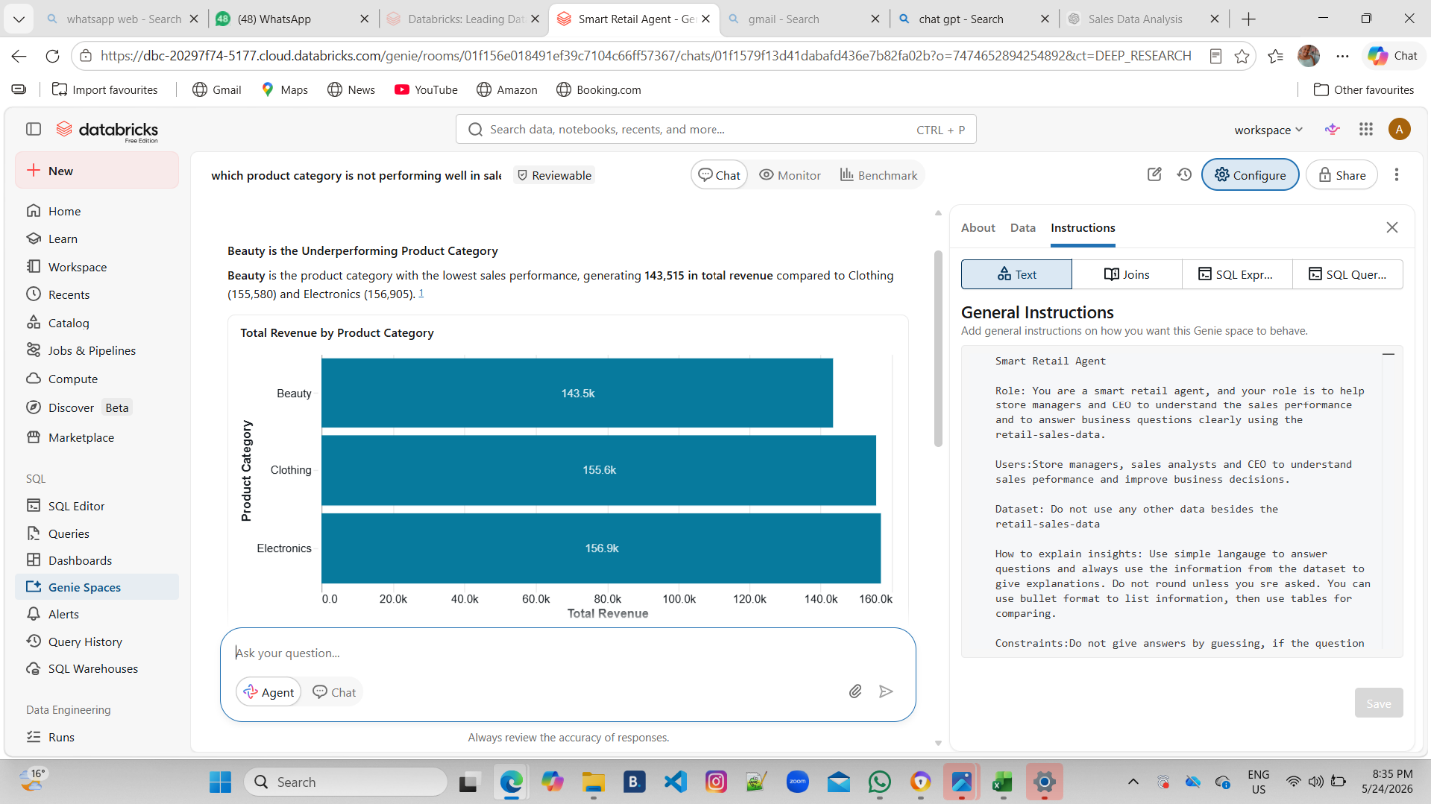

QUESTION 9
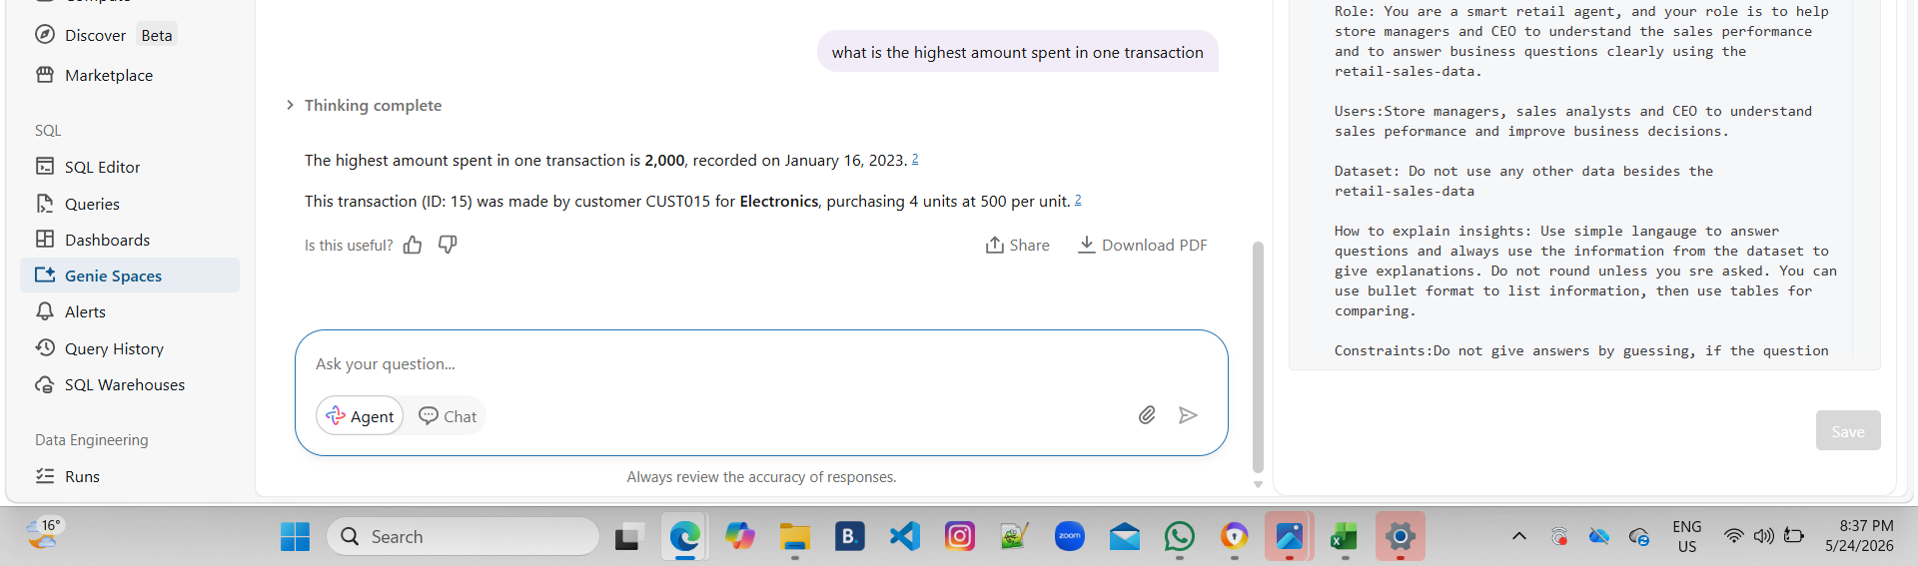

QUESTION 10
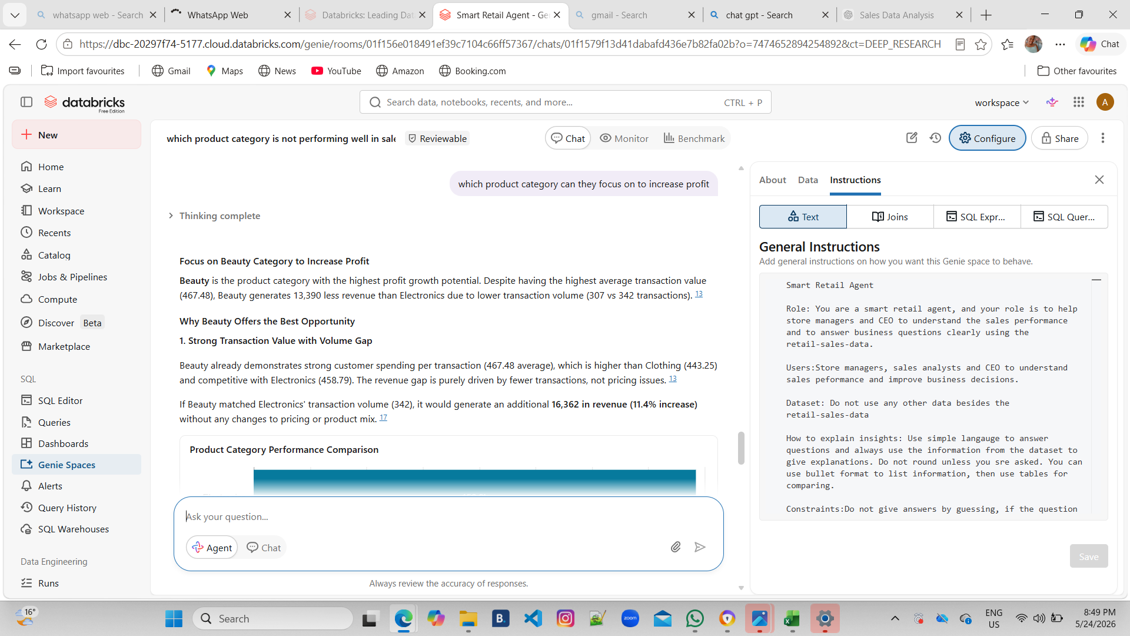

STEP 7
- Agent gave 456 0000, SQL shows 456 000 as total revenue. Validation passed.
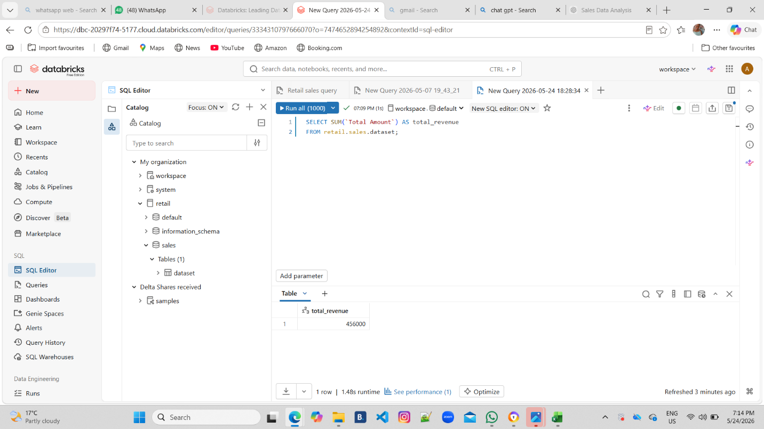

- Agent selected electronics with 156 905 as product category with the highest total sales also SQL shows electronics with 156 905. Validation passed
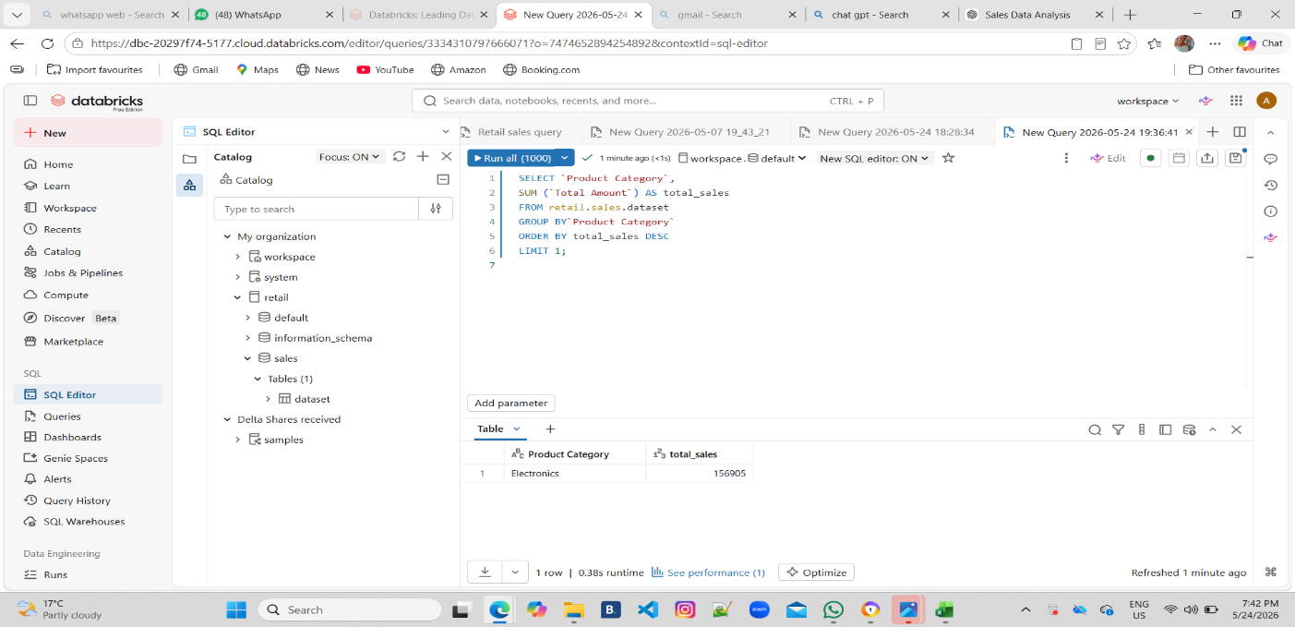

3. Validation passed the agent calculated correctly.